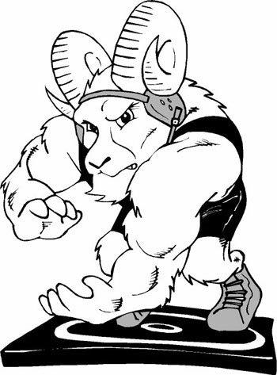
Ram Wrestling Club
Registration- Ages 5-14
Monday, January 29, 2024
6:00PM- 7:30PM

Franklin Middle School Front Entrance
Registration fee: $60 (includes T-Shirt, practices)
First Practice will be Monday, February 12. There will be a short parent meeting before the first practice. Practices will be 2/12, 2/13, 2/19, 2/20, 2/26, 2/27, 3/4, 3/5, 3/11, 3/12, and end March 25th with an ice cream social. At Highland High School Commons Area
Please bring your current insurance information to registration.
Text Coach Kelly Moysh 801.230.1989 or Travis Bell 208-530-0293 with any questions.
Late registration fee: $70

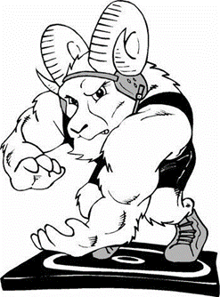
Ram Wrestling Club
Registration- Ages 5-14
Monday, January 29, 2024
6:00PM- 7:30PM

Franklin Middle School Front Entrance
Registration fee: $60 (includes T-Shirt, practices)
First Practice will be Monday, February 12. There will be a short parent meeting before the first practice. Practices will be 2/12, 2/13, 2/19, 2/20, 2/26, 2/27, 3/4, 3/5, 3/11, 3/12, and end March 25th with an ice cream social. At Highland High School Commons Area
Please bring your current insurance information to registration.
Text Coach Kelly Moysh 801.230.1989 or Travis Bell 208-530-0293 with any questions.
Late registration fee: $70

